Dataset download and use instructions

The GermND-3M dataset covers hyperspectral image data (HSID), volatile gas signal data (VGD), grain phenotypic image data (PID), variety labels (VAL), quality label (QL), and viability labels (VL) for a total of 3,214 varieties (germplasms) of four staple crops including rice, wheat, maize, and soybean (RWMS). Each variety comprised 100 seeds. Specifically, There are 100,000, 55,500, 100,000, and 57,600 samples in HSID, for RWMS, respectively. There are 1,000, 557, 1,000, and 619 samples in VGD, for RWMS, respectively. There are 3,000, 59,500, 4,400, and 26,000 samples in PID, for RWMS, respectively. There are 100,000, 59,500, 100,000, and 61,900 samples in VAL, for RWMS, respectively. There are 3,000 samples in QL for both maize and soybean. VL is divided into two types: single-seed VL and population-seed VL. There are 100,000, 55,500, 100,000, and 57,600 samples in Single-seed VL, for RWMS, respectively. There are 1,000, 557, 1,000, and 619 samples in Population-seed, for RWMS, respectively. The GermND-3M dataset is released under a data usage agreement (DUA) through the Crop Germplasm Detection Platform (https://ncgb.germpdet.cn/data/admin/datasets), operated by the National Crop Genebank, Chinese Academy of Agricultural Sciences, Beijing, China. For peer-review purposes, unrestricted download is temporarily enabled, allowing reviewers to access the dataset without completing the agreement.
1. GermND-3M dataset detailed contents
1.1 Hyperspectral image data & variety–single-seed viability label
There are 100,000, 55,500, 100,000, and 57,600 samples in HSID, with corresponding VAL and single-seed VL, for RWMS, respectively. Each sample containing 227 numeric columns. Column 1 is the VAL, column 2 is the sample number, columns 3 to 226 correspond to the average values of spectral reflectance for the 224 bands collected by the hyperspectral image (HSI) collection system respectively, and column 227 is the single-seed VL ('0' indicates non-viable, '1' indicates viable). These data are available in the following files: Rice_HSID_VAL_V
L.xlsx, Wheat_HSID_VAL_VL.xlsx, Maize_HSID_VAL_VL.xlsx, and Soybean_HSID_VAL_VL.xlsx.
1.2 Hyperspectral image data & variety–quality label
There are 3,000 samples in HSID, with corresponding VAL and QL for both maize and soybean. For maize, each sample containing 229 numeric columns. Column 1 is the VAL, Column 2 is the sample number, columns 3 to 226 correspond to the average values of spectral reflectance for the 224 bands collected by the HSI collection system respectively, and column 227 to 229 is the QL. These data are available in the following files: Maize_HSID_VAL_QL.xlsx. For soybean, each sample containing 228 numeric columns. Column 1 is the VAL, Column 2 is the sample number, columns 3 to 226 correspond to the average values of spectral reflectance for the 224 bands collected by the HSI collection system respectively, and column 227 to 228 is the QL.These data are available in the following files: Soybean_HSID_VAL_QL.xlsx.
1.3 Volatile gas signal data & variety–population-seed viability label
There are 1,000, 557, 1,000, and 619 samples in VGD, with corresponding VAL and population-seed VL, for RWMS, respectively. Each sample containing 13 numeric columns. Column 1 is the VAL, Column 2 is the sample number, columns 3 to 12 correspond to the average values of signals collected over 200 seconds by the 10 sensors in the volatile gas signal (VGS) collection system respectively, and column 13 is the population-seed VL (the proportion of seeds that had germinated by day 7, i.e., germination percentage). These data are available in the following files: Rice_VGD_VAL_VL.xlsx, Wheat_VGD_VAL_VL.xlsx, Maize_VGD_VAL_VL.xlsx, and Soybean_VGD_VAL_VL.xlsx.
1.4 Volatile gas signal data & variety–quality label
There are 3,000 samples in VGD, with corresponding VAL and QL for both maize and soybean. For maize, each sample containing 15 numeric columns. Column 1 is the VAL, column 2 is the sample number, columns 3 to 12 correspond to the average values of signals collected over 200 seconds by the 10 sensors in the VGS collection system respectively, and column 13 to 15 is the QL. These data are available in the following files: Maize_VGD_VAL_QL.xlsx. For soybean, each sample containing 14 numeric columns. Column 1 is the VAL, column 2 is the sample number, columns 3 to 12 correspond to the average values of signals collected over 200 seconds by the 10 sensors in the VGS collection system respectively, and column 13 to 14 is the QL. These data are available in the following files: Soybean_VGD_VAL_QL.xlsx.
1.5 Grain phenotypic image data & variety–single-seed viability label
There are 3,000, 59,500, 4,400, and 26,000 samples in PID, with corresponding VAL and single-seed VL, for RWMS, respectively. Each sample containing 14 numeric columns. Column 1 is the VAL, column 2 is the sample number, columns 3 to 13 correspond to the 11 image features extracted from PID respectively, and column 14 is the single-seed VL ('0' indicates non-viable, '1' indicates viable). These data are available in the following files: Rice_PID_VAL_VL.xlsx, Wheat_PID_VAL_
VL.xlsx, Maize_PID_VAL_VL.xlsx, and Soybean_PID_VAL_VL.xlsx.
1.6 Grain phenotypic image data & variety–quality label
There are 3,000 samples in PID, with corresponding VAL and QL for both maize and soybean. For maize, each sample containing 16 numeric columns. Column 1 is the VAL, column 2 is the sample number, columns 3 to 13 correspond to the 11 image features extracted from PID respectively, and column 14 to 16 is the QL. These data are available in the following files: Maize_PID_VAL_QL.xlsx. For soybean, each sample containing 15 numeric columns. Column 1 is the VAL, column 2 is the sample number, columns 3 to 13 correspond to the 11 image features extracted from PID respectively, and column 14 to 15 is the QL. These data are available in the following files: Soybean_PID_VAL_QL.xlsx, respectively.
- Crop Germplasm Detection Platform
Crop Germplasm Detection Platform is a specialized, intelligent web platform designed for crop germplasm detection. It provides validated dataset download links and basic training utilities (e.g., core operators) for viability detection models. Built on the GermND-3M dataset and research outputs reported, the platform provides an end-to-end solution for researchers and agricultural practitioners, covering data processing, model execution, and detection analysis. The platform is organized into modules spanning user access management, the core detection pipeline, and data/model resource governance, with differentiated permissions for administrators and regular users. The GermND-3M dataset can be downloaded from the platform’s Data Library interface, as shown in Fig. 1.
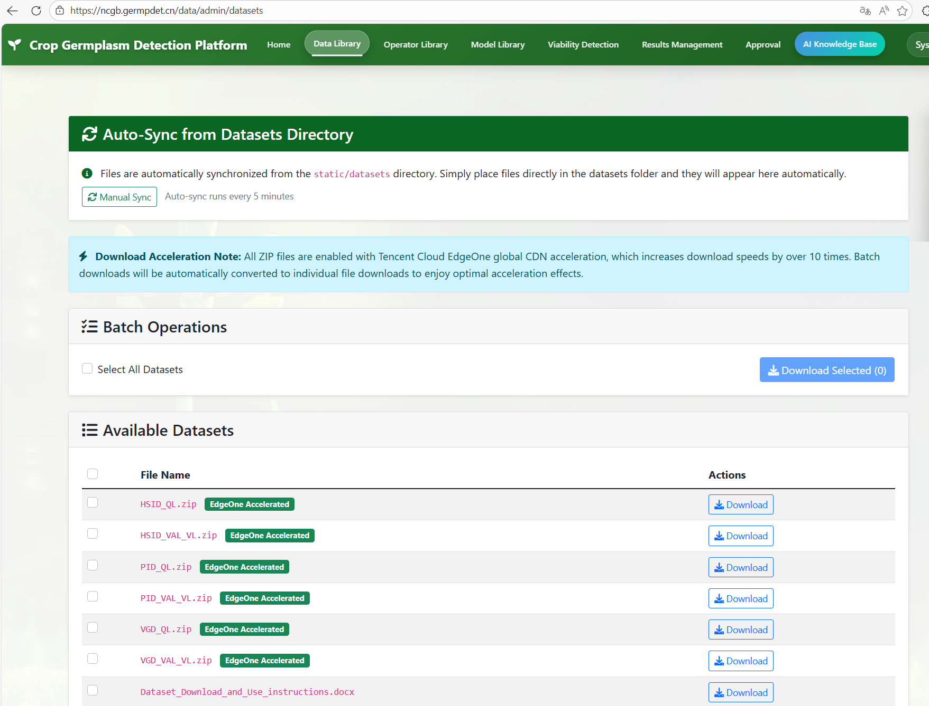
Fig. 1 Data Library interface.

